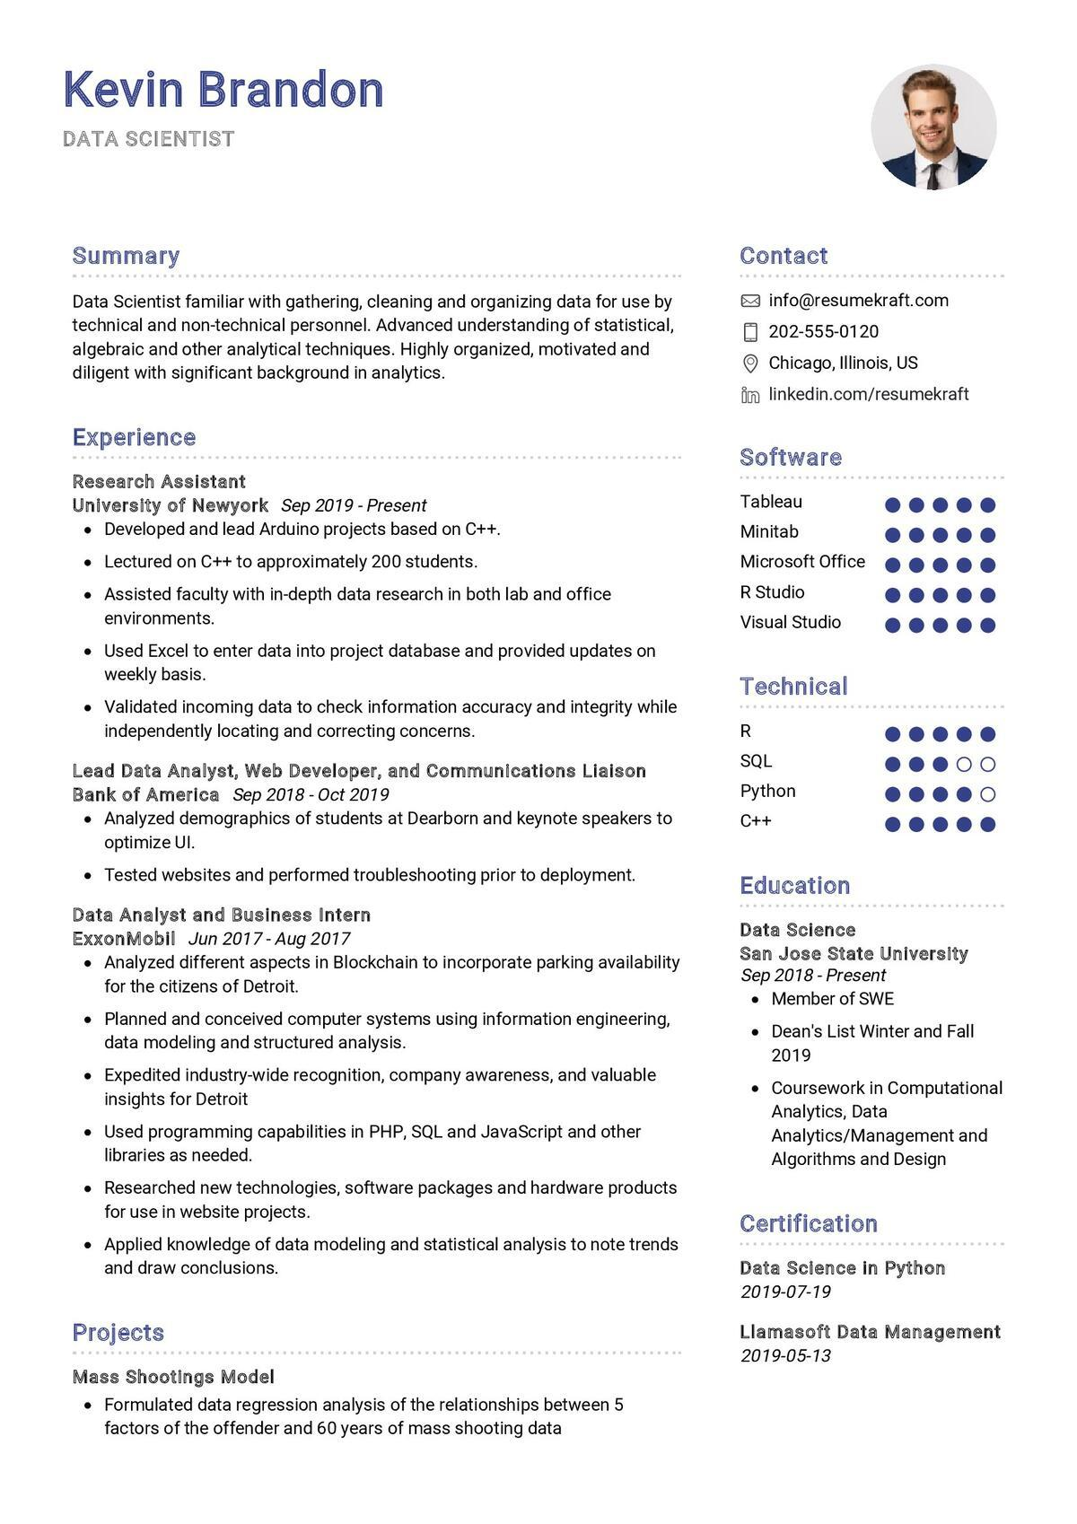
Kevin Brandon
DATA SCIENTIST
Summary
Data Scientist familiar with gathering, cleaning and organizing data for use by technical and non-technical personnel. Advanced understanding of statistical, algebraic and other analytical techniques. Highly organized, motivated and diligent with significant background in analytics.
Experience
Research Assistant
University of Newyork Sep 2019 - Present
Developed and lead Arduino projects based on C++.
• Lectured on C++ to approximately 200 students.
• Assisted faculty with in-depth data research in both lab and office environments.
• Used Excel to enter data into project database and provided updates on weekly basis.
• Validated incoming data to check information accuracy and integrity while independently locating and correcting concerns.
Lead Data Analyst, Web Developer, and Communications Liaison Bank of America Sep 2018 - Oct 2019
• Analyzed demographics of students at Dearborn and keynote speakers to optimize UI.
• Tested websites and performed troubleshooting prior to deployment.
Data Analyst and Business Intern
ExxonMobil Jun 2017- Aug 2017
Analyzed different aspects in Blockchain to incorporate parking availability for the citizens of Detroit.
• Planned and conceived computer systems using information engineering, data modeling and structured analysis.
·
Expedited industry-wide recognition, company awareness, and valuable insights for Detroit
• Used programming capabilities in PHP, SQL and JavaScript and other libraries as needed.
• Researched new technologies, software packages and hardware products for use in website projects.
• Applied knowledge of data modeling and statistical analysis to note trends and draw conclusions.
Projects
Mass Shootings Model
• Formulated data regression analysis of the relationships between 5 factors of the offender and 60 years of mass shooting data
Contact
info@resumekraft.com
202-555-0120
Chicago, Illinois, US
in linkedin.com/resumekraft
Software
Tableau
Minitab
Microsoft Office
R Studio
Visual Studio
Technical
R
SQL
Python C++
Education
Data Science
San Jose State University Sep 2018-Present
• Member of SWE
• Dean's List Winter and Fall 2019
⚫ Coursework in Computational Analytics, Data Analytics/Management and Algorithms and Design
Certification
Data Science in Python 2019-07-19
Llamasoft Data Management 2019-05-13

